Quilted Travel Tote

Supplies:
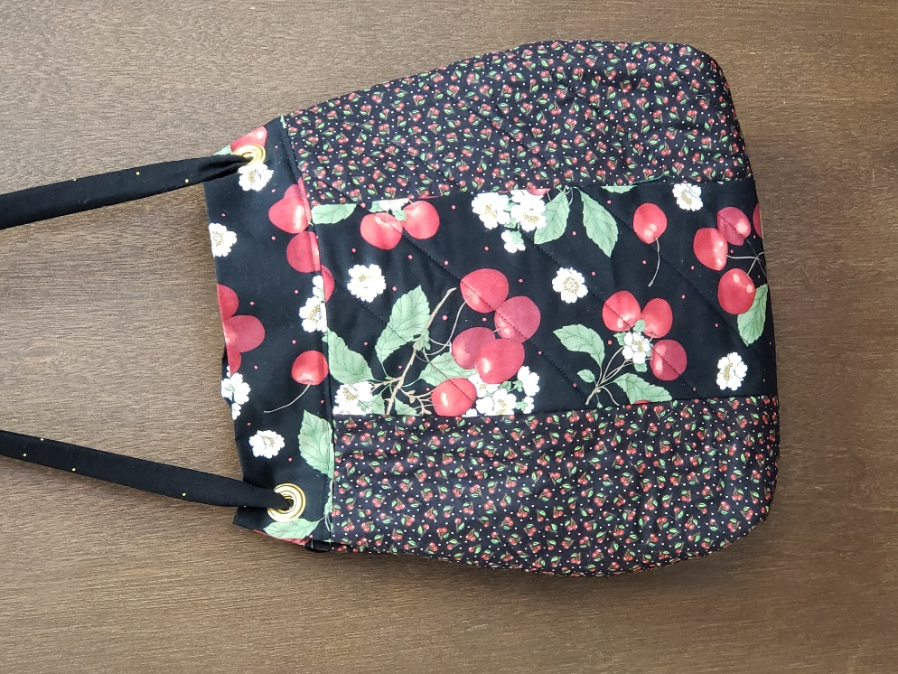
- Fabric A: Four pieces 6”x 14” side pieces
for front and back
- Fabric B: Two pieces 6” x 14” center pieces
for front and back
- Fabric C: Two pieces 6” x 16” for top band
Two pieces 18” x 14” for lining
One piece 4” x 44” (width of fabric” for strap
- Cotton batting: Two pieces 18” x 14”
- Four Dritz grommets: size 7/16”
- Grommet Setting tool and hammer
- Construction Thread
- Wonder Tape
- ¼” Foot with Guide
- All-Purpose sewing foot
- Open Toe foot
- Fabric marker
- Ruler
- Point turner
- Pins
- Temporary Spray Adhesive

Instructions:
- Thread machine with construction thread and select a straight stitch in center needle position. Attach the ¼” foot.

- Construct the front and back panels by sandwiching Fabric B in between the Fabric A rectangles along the 14” sides. Sew in this order A-B-A with a ¼” seam along the 14” edges.

- Press the seams toward the center panel.

- On a protected work surface, place the lining wrong side facing up, batting and the pieced section, right side facing up. Secure the layers together by pinning or spraying the batting with a temporary spray adhesive.

- Using the fabric marker and ruler, draw diagonal lines across the pieces sections, spacing the lines 2” apart.

- Attach the open toe foot and adjust the stitch length to 3.0. Quilt the layers together by sewing on the lines.

- Trim front and back pieces to 13” x 16”.

- Attach the ¼” foot. Needle should still be in center position. With right sides together, sew the band to the front and back along the 16” edge.

- Press the seam toward the band.

- Apply Wonder Tape to the wrong side of the band along the 16” edge. Before removing the protective paper, fold and press to wrong side using the paper as a guide for the perfect ¼” crease. Unfold, remove paper and press into place.

- Apply another piece of Wonder Tape between the band and the quilted section. The tape is positioned between the seam line and the raw edge. Do not remove the paper at this time. Attach the all-purpose sewing foot. Sew the side seams, right sides together, using the edge of the foot as a guide.

- Sew the bottom seam in the same manner.

- Create a boxed bottom by matching the bottom seam with the side seam which creates a triangle. Sew across the triangle approximately 1” from the point. Cut off the triangle leaving a ¼” seam.

- Press wrong side out, put over ironing board end, press band in half.

- Remove the protective paper from the Wonder Tape. Fold the band in half so the creased edge covers the seam. Topstitch in place, moving the needle so it falls close to the edge.

- Attach the ¼” foot and select center needle position.

- Create the strap by folding the fabric in half, right sides together, so it measures 2” x 44”. Round off the short ends slightly. Sew down the length of the strap, leaving a 2” opening for turning, near the center of the strap. Trim Close to the stitching and turn right side out. Use a point turner to smooth seam and press. Sew opening closed.

- The top edge of the bag will be pulled in by pushing in the band’s side seams toward the center approximately 1”. Install the four grommets in the band. There will be one on the left front pleat and one on the left back pleat. Repeat on the right side.

- Insert the strap from the back to the front through the grommets. Ties a large know on the ends to secure.
Adjustments to match bag in video with Karen
- No grommets
- Two straps: 3” x 41” each
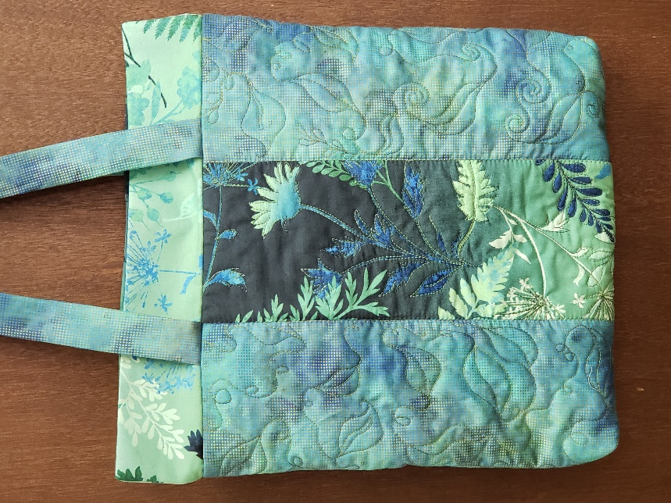
- Add pockets if desired

